Oxford Friends of the Earth Trees Campaign

There is a clear need to increase tree planting in the UK on a very large scale. The UK Committee on Climate Change has called for three billion trees to be planted by 2050. Recent research has shown the potential for large-scale tree planning to absorb CO2. Friends of the Earth is campaigning nationally to double tree cover across the UK as part of wider plans to tackle the climate crisis.
Oxford Friends of the Earth is now planning to work across Oxfordshire to support this work through a combination of advocacy, awareness and practical action. We are very aware of the need for the ‘Right trees in the right place at the right time’.
Our overall aims are:
- To support FoE’s national campaign to get the UK Government and devolved bodies to commit (by December 2020) to double tree cover.
- To at least double tree cover in Oxfordshire to absorb CO2 emissions and increase biodiversity.

[There are around 23,203 ha of woodland (73% of it deciduous) that cover c.9% of the county, and this figure has grown in recent years. The regional average is about 15% and tree cover across England is currently at c. 10%. The extent and type of cover varies greatly throughout the county. In the Oxfordshire Chilterns, woodland cover averages around 25%. Further information on these figures and land availability is below.]

Our goals for this campaign are:
- To get MPs and the county, district and town / parish councils to commit to supporting this campaign, to agree county-level targets and to lobby national government with us.
- To work with planning authorities, land-owners and other relevant bodies to agree strategic places where more trees could be planted on a large scale.
- To build an open coalition of organisations working in Oxfordshire to increase tree cover to help maximise impact and build resources and skills.
- To mobilise at least 20 communities / organisations to each plant at least 200 trees in a suitable local area during November / December 2019 (linked to National tree Week) and to plant more in the spring of 2020.
- To encourage schools, colleges, faith groups, businesses to plant on land they control.
- To develop a network of groups and people to help make this happen and to ensure that trees that are planted are well maintained.

Work with councils
Many councils have declared a ‘climate emergency’. Supporting and encouraging tree planting should be one part of the actions that they take to tackle climate change. This should include identifying areas for new woodlands and also embedding the need for enhanced tree cover in planning guidelines. This will need increased cooperation between those working on green spaces, planning, biodiversity and climate.

Landowners and farmers
Working with these people and organisations will be important to maximise impact. We will look to identify and approach major landowners. This is an important issue for Oxford given the large land holdings of some of the Oxford University colleges.

Other woodland-focused organisations
We will look to develop cooperative working with other organisations and have already had some positive responses. We will develop an advisory group for the campaign to help with this.

Community level planting
We will look to engage with local organisations to encourage and help them to identify suitable spaces, get agreement for planting and carry it out, ideally during Tree Week in November / December 2019 as a first step. This could include community groups, youth groups, faith-based organisations, health / therapy groups, schools, and others.

Our actions
From the above, we need to:
- Identify organisations (and tree experts) who might be involved or are already involved – councils, academics, NGOs, vol groups, schools, colleges etc. and look at how we contact them and develop a database for this.
- Be clear on the information materials we need to get people engaged (a ‘call to action’, web pages and social media) and produce them.
- Establish a Working Group to coordinate the work
- Build the skills of those involved in terms of engaging with landowners, communities etc. and in understanding land ownership and management issues
- Identify land where tree planting would be appropriate and make contact with land owners.
- Consider holding some form of ‘tree summit’ or workshop to bring together interested groups.

First steps (for further discussion)
- Draft and agree some text for a letter to promote the campaign, for webpages and social media and set up a Trees Fbook page to help build an awareness programme (see below).
- Contact key people and organisations
- Hold a first meeting to discuss the points above and set up Working Group. This might also link to a discussion with Guy Shrubsole for FoE on land issues (planned for August 13th).
- Look at how we raise money for trees and tools etc. – maybe we can do a ‘sponsor a tree’? Can we develop a tool bank with SHARE Oxford?
- Identify sources of trees
- Consider building our skills – what skills do we need?
- Look at setting up a map of possible sites
- Think about spin-off issues – health benefits; rewilding; building from wood; biochar; awareness (tree parties?); arts /culture; photo records of change; tree nurseries

Follow Oxford FoE ‘Trees for Climate – Oxfordshire’: https://www.facebook.com/groups/oxfordshiretreesforclimate/
More information: www.oxfoe.co.uk/oxford-friends-of-the-earth/nature/trees-for-climate-oxfordshire/

Background information for the campaign
There are around 23,203 ha of woodland (73% of it deciduous) that cover c.8.9% of Oxfordshire (this figure varies on different sites). That’s up from 17,000 hectares about a decade ago. The regional average is about 15%. The extent and type of cover varies greatly throughout the county. In the Oxfordshire Chilterns, woodland cover averages around 25%.
The area of woodland in the UK at 31 March 2019 is estimated to be 3.19 million hectares. This represents 13% of the total land area in the UK, 10% in England, 15% in Wales, 19% in Scotland and 8% in Northern Ireland. Thirteen thousand hectares of newly created woodland were reported in the UK in 2018-19. https://www.forestresearch.gov.uk/tools-and-resources/statistics/statistics-by-topic/woodland-statistics/
FoE’s campaign is here: https://friendsoftheearth.uk/trees and the background research paper is here: https://policy.friendsoftheearth.uk/insight/why-uk-should-double-forest-area-curb-climate-change
Tree planting is happening faster than expected a few years ago but is still too slow. From the Woodland Trust: “The CCC analysis outlines that 32,000 hectares annually of net woodland increase is required for the next 30 years, moving the UK from 13% to 17% woodland cover. This equates to a million new hectares of woodland cover, and some 1.5 billion trees.” The recommended figure is now 19% - FoE is going for 26%. A general figure of 1500 trees per hectare seems to be widely used.
The new (July 2019) research on global tree cover and major potential climate change impacts is here: https://www.bbc.co.uk/news/science-environment-48870920 The research abstract is here: https://science.sciencemag.org/content/365/6448/76
The Committee on Climate Change research on land use and climate is here:
https://www.theccc.org.uk/2018/11/15/reforms-must-prepare-the-uk-countryside-for-climate-change-and-ensure-that-our-use-of-land-supports-reduced-emissions/
The Royal Society 2018 report on Greenhouse Gas Removal estimated that planting 1.2 million hectares of forest (taking UK woodland cover to c18%) would deliver annual carbon sequestration of 15 MtCO2 per year. This suggests therefore that doubling tree cover by planting 3 million hectares of land would deliver around 37 MtCO2 per year: https://royalsociety.org/-/media/policy/projects/greenhouse-gas-removal/royal-society-greenhouse-gas-removal-report-2018.pdf
It’s estimated that trees “forestall a bill to the health service worth £6.5m pa through removing the 400 tonnes of air pollutants they suck up that would otherwise be suffusing our lungs” (Wild Oxfordshire report 2017).
There was a Forest of Oxford programme - http://www.oncf.org.uk/tund/f04.html - it is inactive at present. The Oxfordshire Woodland Group are supportive of a new initiative. http://www.townsinbritain.co.uk/oxfordsire/forestofoxford.html
On 8th July 2019 Cllr Susan Brown, leader of Oxford City Council wrote to Oxford FoE: “The tree planting is a great initiative which I am sure that … other councillors would be delighted to work with you on delivering. I am happy to hear more about this too and help in any way I can as this is, I’m sure, one of the measures that our Assembly will be looking at to help us deliver our goals.”
The Woodland Trust have free tree packs (though we need to know where the trees will be planted).
The International Tree Foundation (http://internationaltreefoundation.org/ ) are based in Oxford and have some funds available for local planting.
Natural England 2011 state that “Only half of people in England live within 300 metres of green space” http://publications.naturalengland.org.uk/file/80007
Current government targets for tree-planting are wholly inadequate – the Conservatives have pledged merely to increase England’s forest cover from the current 10% to 12% by 2060.
How many trees? 1500 trees per hectare seems standard. Typical planting densities include:
• Planted every 3 metres – 1,100 trees per hectare
• Planted every 2.5 metres – 1,600 trees per hectare
• Planted every 2 metres – 2,500 trees per hectare

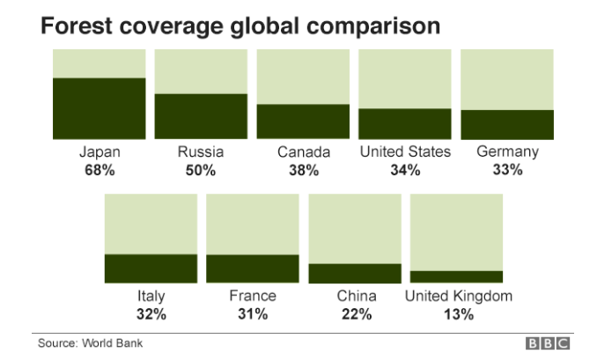

Reality Check: Are millions of trees being planted? (2017) https://www.bbc.co.uk/news/science-environment-41551296
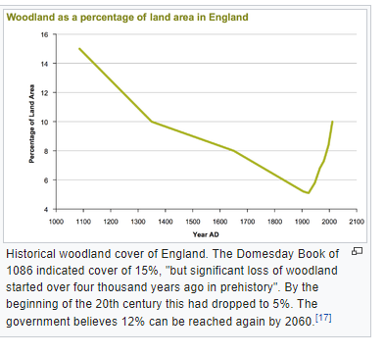
Thhsi diagram shows how tree cover reached an all time low during WW1 and is developing now (but not fast enough).

